Technical Committee Members and Judge

技術委員及裁判名單

**Technical Delegate (TD)/**技術委員召集人：翁明祥

**TD Member/**技術委員：劉文宏、歐陽昭勇、張助道、彭紹武、鍾永貴、戴國輝

**Chief Secretary/**大會秘書：曾昱彰

**Chief Judge/**裁判長：林子競

**Main Judge/**主裁判：丁奕先、嚴婉毓、周文愷、姜秀美

**Starter/**發令：張韶芹、 顏銓良

**Chief** **Safety/**戒護長：王聖昕

**Deputy Chief Safety/**副戒護長：嚴婉毓(兼)

**Safety/**安全戒護裁判：劉家誠、李晉嘉、曾則翰、梁孟弘、喻祚凡、陳怡緻、

劉 昕、陳怡君、林克倫、許志豪、卓湘婷、孫婷南、古銘榮

**Chief Time Keeper/**計時主任：蔡堯生

**Keeper/**計時裁判：鍾哲豪、李芸媖、吳寶昇

**Chief Prestart/**檢錄主任：陳崇恩

**Prestart/**檢錄組：蘇翊詮、蔡濰楷、張偉生

**Warm-up Judge/**暖身裁判：楊隆富、曾奕軒、馬瑞祥

**Video Judge/**攝影裁判：謝雲竹、趙元、黃貫淳、湯澐星

**Equipment & Judge Materials Management/**裁判器材管理: 周廷衞，饒建榮

**Record/**記錄組：葉桑柔、張育瑜

**IT/**資訊組：楊立群、黃泓瑋

**Doctor/**醫療救助人員：台灣緊急救護協會

**Speaker/**播報組：蔡宛玹、莊憲源

**Master of Ceremonies/**典 禮 主 任：黃嶽龍

**Ceremonies/**典禮人員：吳健華、陳美杏、黃貴華、志工

**Information Service/**服務人員：蔡宛玹(兼)、侯言芳、李雅惠

**Photography/**攝影人員：吳宗昌、陳錦昌、吳正安

**Underwater Photography/**水中攝影：鄒猷新、張家維

**Venue & Equipment Team:/**場地器材組：戒護人員兼任

**Mobile Support Team:/**機動組: 張忠峰、曾志賢、吳敏章

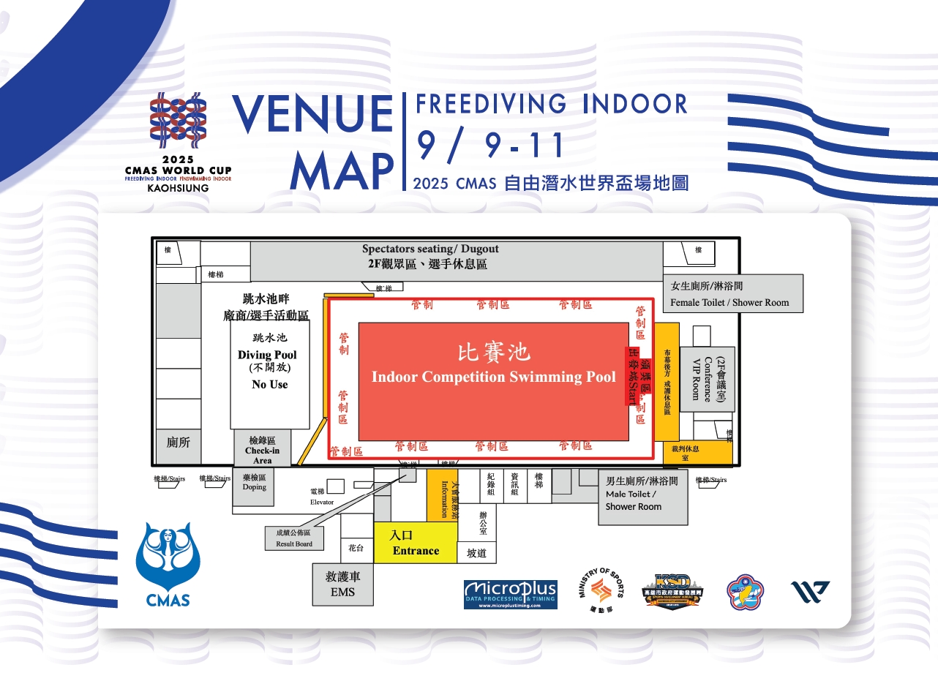

參加人數統計表/ Participant Statistics Table

|  |  |  |  |  |
| --- | --- | --- | --- | --- |
| NO | Given Name | Family Name | Gender | Nationality |
| 1 | Olivia | TANG | female | China |
| 2 | Sabine | MANZ | female | Ecuador |
| 3 | Dmitri | MELNIKOV | male | Estonia |
| 4 | Darryl | PALMER | male | Great Britain |
| 5 | Sze Kwan Freddie | CHAN | male | Hong Kong, China |
| 6 | Shiela Rhea | MARIANO | female | Philippines |
| 7 | Chuck Faustin | ARMOREDA | male | Philippines |
| 8 | Tracy | ROXANNE | female | Philippines |
| 9 | Ida Felisse | MARASIGAN | female | Philippines |
| 10 | Irene | VILLAFLOR | female | Philippines |
| 11 | Rolly | BEN | male | Philippines |
| 12 | Ernie | WONG | male | Singapore |
| 13 | Vootipong | LIMPANITIVAT | male | Thailand |
| 14 | Yufang | LIU | female | Chinese Taipei |
| 15 | Tang Yu | LIU | male | Chinese Taipei |
| 16 | Yu-Han | LIU | female | Chinese Taipei |
| 17 | Ming-Chou | PAN | male | Chinese Taipei |
| 18 | Kai-Hsiang | CHAN | male | Chinese Taipei |
| 19 | Hsin-Ju | LIN | female | Chinese Taipei |
| 20 | Yung-Yen | CHEN | female | Chinese Taipei |
| 21 | Yixian | ZHANG | male | Chinese Taipei |
| 22 | Yanting | LI | male | Chinese Taipei |
| 23 | Kun-Ching | HO | male | Chinese Taipei |
| 24 | Po-Yen | LEE | male | Chinese Taipei |
| 25 | Yu-Chi | WU | female | Chinese Taipei |
| 26 | Wei-Hsuan | YEN | female | Chinese Taipei |
| 27 | Ya-Wen | HUANG | female | Chinese Taipei |
| 28 | Huajui | TSENG | male | Chinese Taipei |
| 29 | Yihua | CHEN | female | Chinese Taipei |
| 30 | Patty | CHEN | female | Chinese Taipei |
| 31 | Xinhui | HUANG | female | Chinese Taipei |
| 32 | Yu- Min | LIU | female | Chinese Taipei |
| 33 | Yueh Shiang | HSU | male | Chinese Taipei |
| 34 | Raymond | KO | male | United States of America |

|  |  |  |
| --- | --- | --- |
| Nationality | Male | Female |
| 10 | 17 | 17 |

|  |  |  |  |  |  |
| --- | --- | --- | --- | --- | --- |
| 2025 CMAS World Cup Freediving Indoor, KAOHSIUNG | | | | | |
| **表一** | 2025/09/09 Official Training: 13:30 ~ 16:00 | | | | |
|  | Lane 0 and 9 : Not for use (camera - video) | | | | |
| **#** | **Country** | **ATHLETES** | **LANE** | **TOTAL** | **Note** |
| 1 | Estonia | 1 | 1 | 4 |  |
| 2 | Great Britain | 1 |  |
| 3 | Hong Kong | 1 |  |
| 4 | China | 1 |  |
| 5 | Philippine | 6 | 2 | 3 |  |
| 3 | 3 |  |
| 6 | Singapore | 1 | 4 | 4 |  |
| 7 | Thailand | 1 |  |
| 8 | United States | 1 |  |
| 9 | Ecuador | 1 |  |
| 10 | Chinese Taipei | 20 | 5 | 5 |  |
| 6 | 5 |  |
| 7 | 5 |  |
| 8 | 5 |  |
|  |  |  |  |  |  |
|  |  |  |  |  |  |
| **表二** | 2025/09/10 Official Training: 08:00 ~ 09:00 | | | | |
|  | Lane 0 and 9 : Not for use (camera - video) | | | | |
| **#** | **Country** | **ATHLETES** | **LANE** | **TOTAL** | **Note** |
| 1 | Chinese Taipei | 20 | 1 | 5 |  |
| 2 | 5 |  |
| 3 | 5 |  |
| 4 | 5 |  |
| 2 | Estonia | 1 | 5 | 4 |  |
| 3 | Great Britain | 1 |  |
| 4 | Hong Kong | 1 |  |
| 5 | China | 1 |  |
| 6 | Philippine | 6 | 6 | 3 |  |
| 7 | 3 |  |
| 7 | Singapore | 1 | 8 | 4 |  |
| 8 | Thailand | 1 |  |
| 9 | United States | 1 |  |
| 10 | Ecuador | 1 |  |

**Freediving World Cup – Opening Ceremony**

2025/09/10(Wednesday)

|  |  |  |
| --- | --- | --- |
| Time | Program (English) | 節目流程 (中文) |
| 09:15 | Opening Performance (Indigenous Dance) | 開場表演（原住民舞蹈） |
| 09:30 | Introduction of Officials and Guests | 長官貴賓介紹 |
| 09:35 | Judges’ Entrance | 裁判進場 |
| 09:40 | Introduction of Judges | 裁判介紹 |
| 09:45 | Speeches by Officials | 長官致詞 |
| 10:00 | Closing the Opening Ceremony | 禮成 |

|  |  |  |  |  |  |  |  |  |  |
| --- | --- | --- | --- | --- | --- | --- | --- | --- | --- |
| 2025/09/10  DNF - DYNAMIC WITHOUT FINS WOMEN START LIST | | | | | | | | | |
| RACE | LANE | NO | NAME | IOC | GENDER | CKIN | WARM UP | LAST 3 MIN | TOP TIME |
| 1 | A | 1 | Xinhui HUANG | TPE | F | 13:00 | 13:15 | 13:57 | 14:00 |
| C | 2 | Ya-Wen HUANG | TPE | F | 13:00 | 13:15 | 13:57 | 14:00 |
| B | 3 | Wei-Hsuan YEN | TPE | F | 13:08 | 13:23 | 14:05 | 14:08 |
| D | 4 | Yu- Min LIU | TPE | F | 13:08 | 13:23 | 14:05 | 14:08 |
| 2 | A | 5 | Irene VILLAFLOR | PHI | F | 13:16 | 13:31 | 14:13 | 14:16 |
| C | 6 | Yufang LIU | TPE | F | 13:16 | 13:31 | 14:13 | 14:16 |
| B | 7 | Yung-Yen CHEN | TPE | F | 13:24 | 13:39 | 14:21 | 14:24 |
| D | 8 | Tracy ROXANNE | PHI | F | 13:24 | 13:39 | 14:21 | 14:24 |
| 3 | A | 9 | Sabine MANZ | ECU | F | 13:32 | 13:47 | 14:29 | 14:32 |
| C | 10 | Yihua CHEN | TPE | F | 13:32 | 13:47 | 14:29 | 14:32 |
| B | 11 | Hsin-Ju LIN | TPE | F | 13:40 | 13:55 | 14:37 | 14:40 |
| D | 12 | Yu-Chi WU | TPE | F | 13:40 | 13:55 | 14:37 | 14:40 |
| 4 | A | 13 | Yu-Han LIU | TPE | F | 13:48 | 14:03 | 14:45 | 14:48 |
| C | 14 | Olivia TANG | CHN | F | 13:48 | 14:03 | 14:45 | 14:48 |

|  |  |  |  |  |  |  |  |  |  |
| --- | --- | --- | --- | --- | --- | --- | --- | --- | --- |
| 2025/09/10  DNF - DYNAMIC WITHOUT FINS MEN START LIST | | | | | | | | | |
| RACE | LANE | NO | NAME | IOC | GENDER | CKIN | WARM UP | LAST 3 MIN | TOP TIME |
| 1 | A | 1 | Sze Kwan Freddie CHAN | HKG | M | 14:08 | 14:23 | 15:05 | 15:08 |
| C | 2 | Dmitri MELNIKOV | EST | M | 14:08 | 14:23 | 15:05 | 15:08 |
| B | 3 | Huajui TSENG | TPE | M | 14:16 | 14:31 | 15:13 | 15:16 |
| D | 4 | Yixian ZHANG | TPE | M | 14:16 | 14:31 | 15:13 | 15:16 |
| 2 | A | 5 | Tang Yu LIU | TPE | M | 14:24 | 14:39 | 15:21 | 15:24 |
| C | 6 | Raymond KO | USA | M | 14:24 | 14:39 | 15:21 | 15:24 |
| B | 7 | Chuck Faustin ARMOREDA | PHI | M | 14:32 | 14:47 | 15:29 | 15:32 |
| D | 8 | Ernie WONG | SIN | M | 14:32 | 14:47 | 15:29 | 15:32 |
| 3 | A | 9 | Kun-Ching HO | TPE | M | 14:40 | 14:55 | 15:37 | 15:40 |
| C | 10 | Vootipong LIMPANITIVAT | THA | M | 14:40 | 14:55 | 15:37 | 15:40 |
| B | 11 | Yueh Shiang HSU | TPE | M | 14:48 | 15:03 | 15:45 | 15:48 |
| D | 12 | Ming-Chou PAN | TPE | M | 14:48 | 15:03 | 15:45 | 15:48 |
| 4 | A | 13 | Po-Yen LEE | TPE | M | 14:56 | 15:11 | 15:53 | 15:56 |
| C | 14 | Kai-Hsiang CHAN | TPE | M | 14:56 | 15:11 | 15:53 | 15:56 |

|  |  |  |  |  |  |  |  |  |  |
| --- | --- | --- | --- | --- | --- | --- | --- | --- | --- |
| 2025/09/11  DYNBF - DYNAMIC BI FINS WOMEN START LIST | | | | | | | | | |
| RACE | LANE | NO | NAME | IOC | GENDER | CKIN | WARM UP | LAST 3 MIN | TOP TIME |
| 4 | B | 1 | Ya-Wen HUANG | TPE | F | 08:00 | 08:15 | 08:57 | 09:00 |
| D | 2 | Ida Felisse MARASIGAN | PHI | F | 08:00 | 08:15 | 08:57 | 09:00 |
| 5 | A | 3 | Yu- Min LIU | TPE | F | 08:08 | 08:23 | 09:05 | 09:08 |
| C | 4 | Irene VILLAFLOR | PHI | F | 08:08 | 08:23 | 09:05 | 09:08 |
| B | 5 | Wei-Hsuan YEN | TPE | F | 08:16 | 08:31 | 09:13 | 09:16 |
| D | 6 | Yufang LIU | TPE | F | 08:16 | 08:31 | 09:13 | 09:16 |
| 6 | A | 7 | Sabine MANZ | ECU | F | 08:24 | 08:39 | 09:21 | 09:24 |
| C | 8 | Yung-Yen CHEN | TPE | F | 08:24 | 08:39 | 09:21 | 09:24 |
| B | 9 | Shiela Rhea MARIANO | PHI | F | 08:32 | 08:47 | 09:29 | 09:32 |
| D | 10 | Tracy ROXANNE | PHI | F | 08:32 | 08:47 | 09:29 | 09:32 |
| 7 | A | 11 | Patty CHEN | TPE | F | 08:40 | 08:55 | 09:37 | 09:40 |
| C | 12 | Hsin-Ju LIN | TPE | F | 08:40 | 08:55 | 09:37 | 09:40 |

|  |  |  |  |  |  |  |  |  |  |
| --- | --- | --- | --- | --- | --- | --- | --- | --- | --- |
| 2025/09/11  DYNBF - DYNAMIC BI FINS MEN START LIST | | | | | | | | | |
| RACE | LANE | NO | NAME | IOC | GENDER | CKIN | WARM UP | LAST 3 MIN | TOP TIME |
| 1 | A | 1 | Dmitri MELNIKOV | EST | M | 09:00 | 09:15 | 09:57 | 10:00 |
| C | 2 | Sze Kwan Freddie CHAN | HKG | M | 09:00 | 09:15 | 09:57 | 10:00 |
| B | 3 | Huajui TSENG | TPE | M | 09:08 | 09:23 | 10:05 | 10:08 |
| D | 4 | Yanting LI | TPE | M | 09:08 | 09:23 | 10:05 | 10:08 |
| 2 | A | 5 | Tang Yu LIU | TPE | M | 09:16 | 09:31 | 10:13 | 10:16 |
| C | 6 | Raymond KO | USA | M | 09:16 | 09:31 | 10:13 | 10:16 |
| B | 7 | Rolly BEN | PHI | M | 09:24 | 09:39 | 10:21 | 10:24 |
| D | 8 | Chuck Faustin ARMOREDA | PHI | M | 09:24 | 09:39 | 10:21 | 10:24 |
| 3 | A | 9 | Ernie WONG | SIN | M | 09:32 | 09:47 | 10:29 | 10:32 |
| C | 10 | Vootipong LIMPANITIVAT | THA | M | 09:32 | 09:47 | 10:29 | 10:32 |
| B | 11 | Ming-Chou PAN | TPE | M | 09:40 | 09:55 | 10:37 | 10:40 |
| D | 12 | Po-Yen LEE | TPE | M | 09:40 | 09:55 | 10:37 | 10:40 |
| 4 | A | 13 | Kai-Hsiang CHAN | TPE | M | 09:48 | 10:03 | 10:45 | 10:48 |

|  |  |  |  |  |  |  |  |  |  |
| --- | --- | --- | --- | --- | --- | --- | --- | --- | --- |
| 2025/09/11  DYN - DYNAMIC WITH FINS WOMEN START LIST | | | | | | | | | |
| RACE | LANE | NO | NAME | IOC | GENDER | CKIN | WARM UP | LAST 3 MIN | TOP TIME |
| 1 | A | 1 | Wei-Hsuan YEN | TPE | F | 13:00 | 13:15 | 13:57 | 14:00 |
| C | 2 | Ya-Wen HUANG | TPE | F | 13:00 | 13:15 | 13:57 | 14:00 |
| B | 3 | Irene VILLAFLOR | PHI | F | 13:08 | 13:23 | 14:05 | 14:08 |
| D | 4 | Yufang LIU | TPE | F | 13:08 | 13:23 | 14:05 | 14:08 |
| 2 | A | 5 | Ida Felisse MARASIGAN | PHI | F | 13:16 | 13:31 | 14:13 | 14:16 |
| C | 6 | Yung-Yen CHEN | TPE | F | 13:16 | 13:31 | 14:13 | 14:16 |
| B | 7 | Sabine MANZ | ECU | F | 13:24 | 13:39 | 14:21 | 14:24 |
| D | 8 | Shiela Rhea MARIANO | PHI | F | 13:24 | 13:39 | 14:21 | 14:24 |
| 3 | A | 9 | Tracy ROXANNE | PHI | F | 13:32 | 13:47 | 14:29 | 14:32 |
| C | 10 | Yu-Chi WU | TPE | F | 13:32 | 13:47 | 14:29 | 14:32 |
| B | 11 | Yu-Han LIU | TPE | F | 13:40 | 13:55 | 14:37 | 14:40 |
| D | 12 | Olivia TANG | CHN | F | 13:40 | 13:55 | 14:37 | 14:40 |
| 4 | A | 13 | Patty CHEN | TPE | F | 13:48 | 14:03 | 14:45 | 14:48 |

|  |  |  |  |  |  |  |  |  |  |
| --- | --- | --- | --- | --- | --- | --- | --- | --- | --- |
| 2025/09/11  DYN - DYNAMIC WITH FINS MEN START LIST | | | | | | | | | |
| RACE | LANE | NO | NAME | IOC | GENDER | CKIN | WARM UP | LAST 3 MIN | TOP TIME |
| 1 | A | 1 | Dmitri MELNIKOV | EST | M | 14:08 | 14:23 | 15:05 | 15:08 |
| C | 2 | Sze Kwan Freddie CHAN | HKG | M | 14:08 | 14:23 | 15:05 | 15:08 |
| B | 3 | Huajui TSENG | TPE | M | 14:16 | 14:31 | 15:13 | 15:16 |
| D | 4 | Tang Yu LIU | TPE | M | 14:16 | 14:31 | 15:13 | 15:16 |
| 2 | A | 5 | Yixian ZHANG | TPE | M | 14:24 | 14:39 | 15:21 | 15:24 |
| C | 6 | Raymond KO | USA | M | 14:24 | 14:39 | 15:21 | 15:24 |
| B | 7 | Chuck Faustin ARMOREDA | PHI | M | 14:32 | 14:47 | 15:29 | 15:32 |
| D | 8 | Yanting LI | TPE | M | 14:32 | 14:47 | 15:29 | 15:32 |
| 3 | A | 9 | Ernie WONG | SIN | M | 14:40 | 14:55 | 15:37 | 15:40 |
| C | 10 | Rolly BEN | PHI | M | 14:40 | 14:55 | 15:37 | 15:40 |
| B | 11 | Kun-Ching HO | TPE | M | 14:48 | 15:03 | 15:45 | 15:48 |
| D | 12 | Vootipong LIMPANITIVAT | THA | M | 14:48 | 15:03 | 15:45 | 15:48 |
| 4 | A | 13 | Darryl PALMER | GBR | M | 14:56 | 15:11 | 15:53 | 15:56 |
| C | 14 | Yueh Shiang HSU | TPE | M | 14:56 | 15:11 | 15:53 | 15:56 |
| B | 15 | Kai-Hsiang CHAN | TPE | M | 15:04 | 15:19 | 16:01 | 16:04 |

**Freediving World Cup Closing Ceremony**

2025/09/11(Thursday)

|  |  |  |
| --- | --- | --- |
| Time | Program (English) | 節目流程 (中文) |
| 16:30 | Individual Medal Awards | 頒發個人獎牌 |
| 16:40 | Overall Individual Points Trophy Awards | 頒發個人總積分獎盃 |
| 16:50 | Lucky Draw (featuring a variety of diving-related items) | 摸彩活動 |
| 17:00 | Closing | 閉幕 |